**Arti_tyagi_system_verilog_2023**

**System Verilog DataTyape**

**Code 1 :**

**Understand the difference between integer and int data type**

Here integer is 4 state variables can store (0,1,x,z) and

Int is new 2 state variable can store only 0 and 1.

**module tb;**

**integer [3:0] a;**

**int [3:0] b;**

**initial begin**

**a = 4'b01xz;**

**b = 4'b01xz;**

**$display("a=%b,b=%b",a,b);**

**end**

**endmodule**

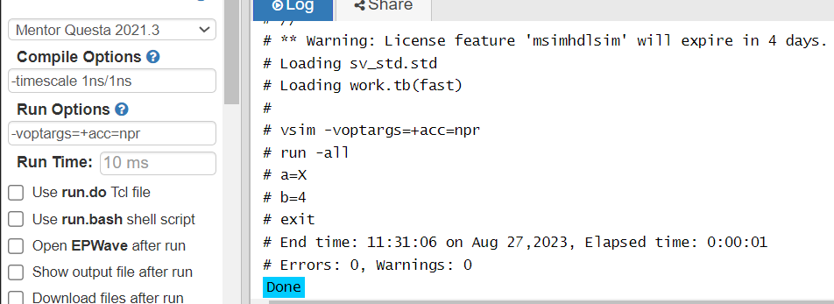

**Code -2**

**Understand the difference between byte ,bit and logic data type**

Here logic is 4 state variables can store (0,1,x,z) , bit and byte

is 2 state data type which is used most often in testbench.

bit and byte can either 0 or 1 which represent single bit.

**module tb;**

**logic [4:0] a; //declare 5 bit logic type variable**

**bit b; //1 bit variable of bit**

**bit[3:0]c;**

**byte d;**

**initial begin**

**a = 4'b01xz;**

**b=1;**

**c = 4'b01xz;**

**d = 4'b01xz;**

**$display("\nlogic data types a=%b,\nbit data types b=%b,\nbit data types c=%b,\nByte data types d",a,b,c,d);**

**end**

**endmodule**

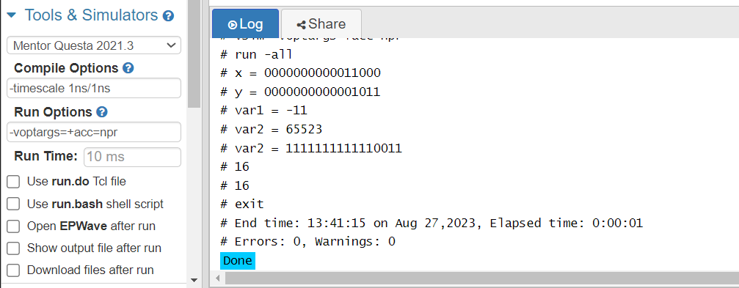

**Code -3**

**Understand the difference between shortint ,bit and logicint**

**data type**

Shortint :- 2 state data type, 16-bit signed integer

Longint :- 2 state data type, 64-bit signed integer

**module tb;**

**shortint x;//variable declaration**

**shortint y = 5'b01011;**

**shortint var1;//signed**

**bit [15:0] var2;//unsigned**

**longint var3;**

**int var4;**

**initial begin**

**x = 16'b110zx;**

**$display("x = %b",x);**

**$display("y = %b",y);**

**var1 = -11;**

**var2 = -13;**

**$display("var1 = %0d",var1);**

**$display("var2 = %0d",var2);**

**$display("var2 = %b",var2);**

**$display("%0d",$size(var1));**

**$display("%0d",$size(var2));**

**end**

**endmodule**



**Code -4**

**Declare integer a,b**

1. **Assign a and b with random values between 10,20.**

**display both the a,b.**

**module tb;**

**integer a,b;**

**initial begin**

**a = $urandom_range(10,20);**

**b = $urandom_range(10,20);**

**$display("a=%0d,b=%0d",a,b);**

**if(a == b)begin**

**$display("equal");**

**end**

**else begin**

**$display(" not equal");**

**end**

**end**

**endmodule**

